**Test Report**

**Use case 1: Recommendation as push notification based customer profile and local providers information**

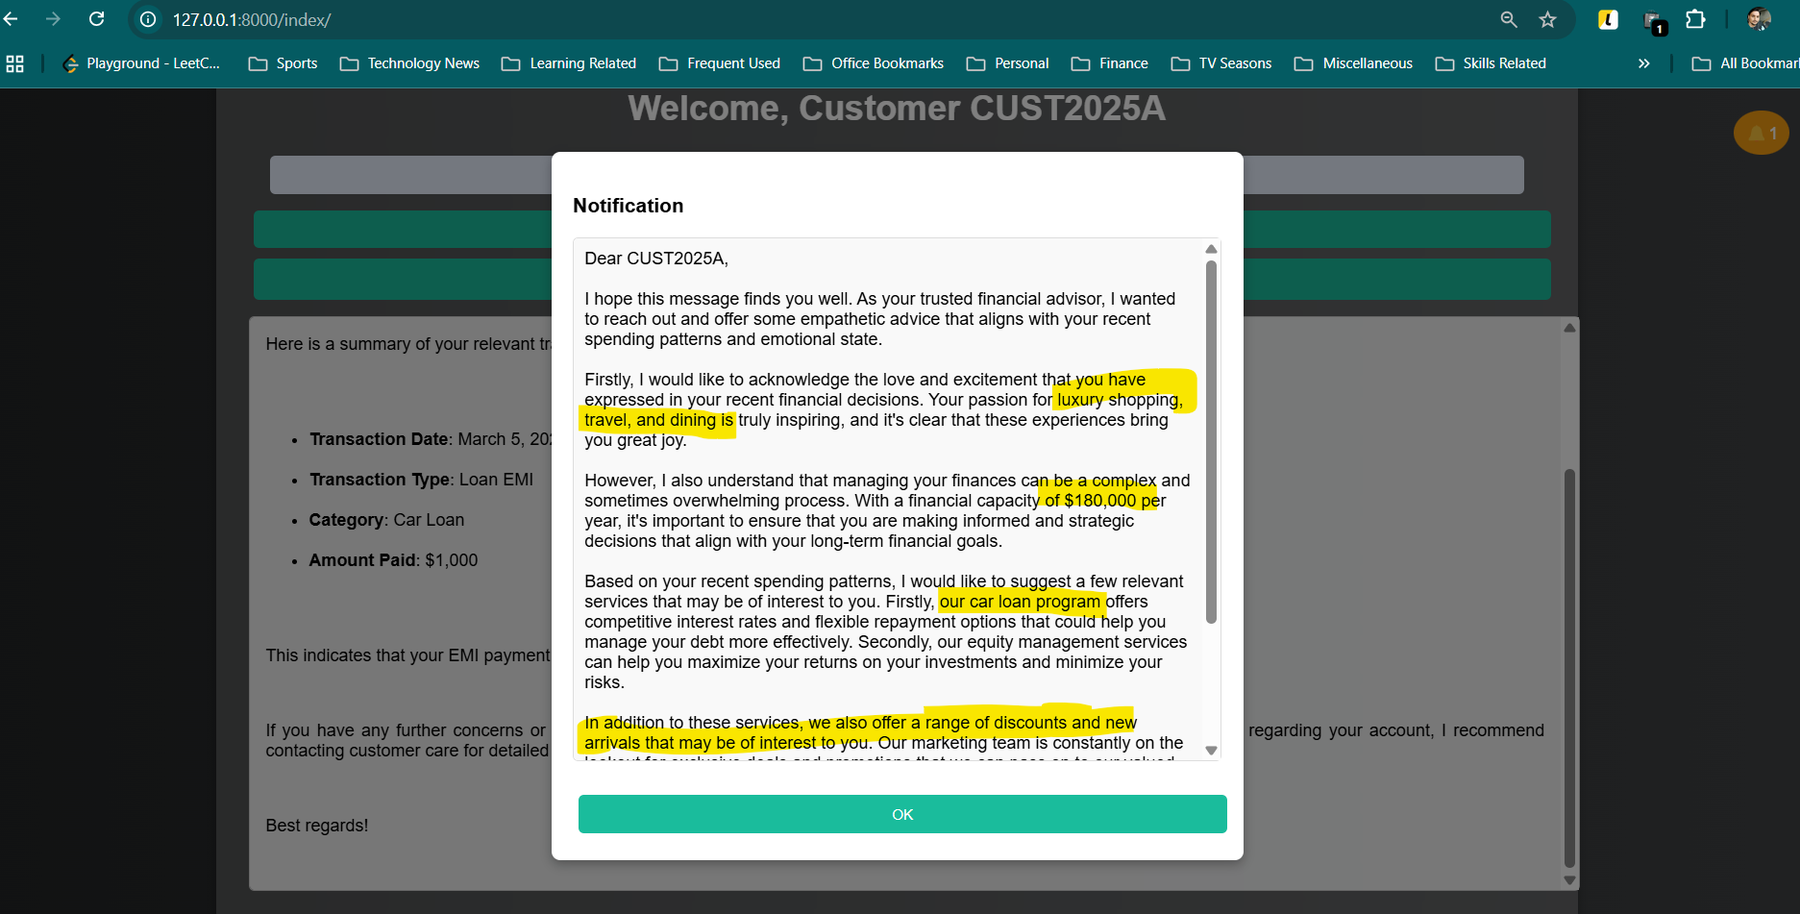

**Use case 2: The user asks a direct question about their personal financial data**

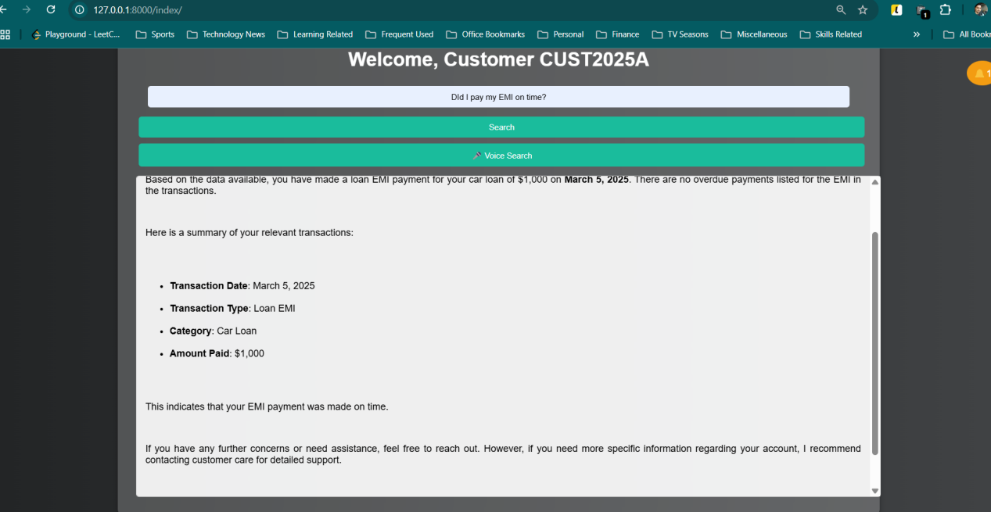

**Use case 3: The customer asks some advice indirectly revealing their sentiment in question.**

